33rd Richmond - Buddha’s Light Scout Group
佛光童軍～列治文第三十三旅
http://www.33richmondscouts.org

Mt Seymour – Group Campsite is located at P1

GOOGLE MAP ADDRESS: https://goo.gl/maps/y4qxA3AB3F62

GPS COORDINATION
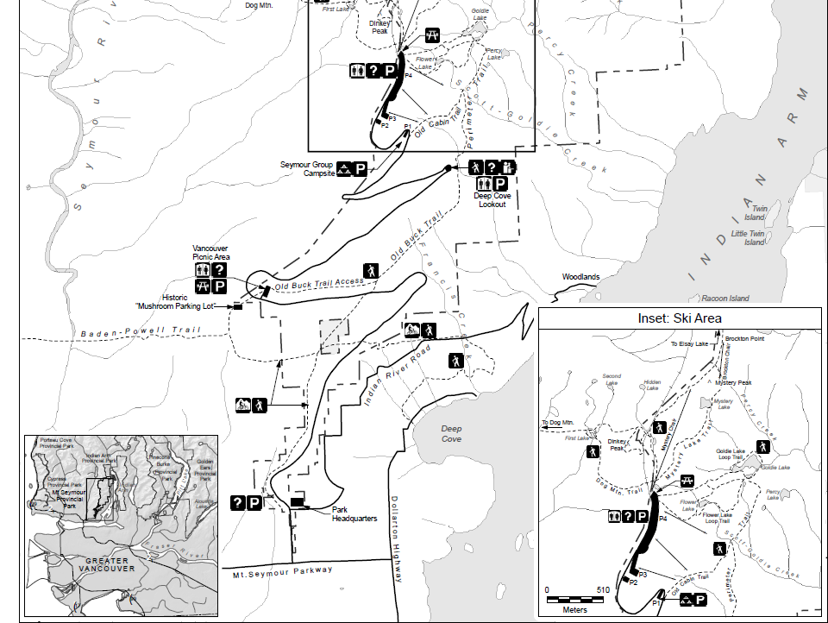
LAT: 49.359199, LONG: -122.948561

