The “firing squad”–4 campers–marched the “prisoners”–4 campers–to the execution spot. You could also pretend that the campers will have water balloons or pies thrown at them instead of being shot, especially if younger campers will be present.)
Firing Squad Leader: (to Prisoner 1) Do you have any last requests?
Prisoner 1: No.
Firing Squad Leader: Ready . . . Aim . . .
Prisoner 1: (points behind the Firing Squad) HURRICANE! (the Firing Squad turns to look and Prisoner 1 runs away)
Firing Squad Leader: That was weird. Looks like we’ve lost a prisoner though. Oh well! Do you have any last requests?
Prisoner 2: No.
Firing Squad Leader: Ready . . . Aim . . .
Prisoner 2: (points behind the Firing Squad) TORNADO! (the Firing Squad turns to look and Prisoner 2 runs away)
Firing Squad Leader: This is so strange. Looks like we’ve lost another prisoner though. Oh well! Do you have any last requests?
Prisoner 3: No.
Firing Squad Leader: Ready . . . Aim . . .
Prisoner 3: (points behind the Firing Squad) FLOOD! (the Firing Squad turns to look and Prisoner s runs away)
Firing Squad Leader: What an odd day! Looks like we’ve lost yet another prisoner though. Oh well! Do you have any last requests?
Prisoner 4: No.
Firing Squad Leader: Ready . . . Aim . . .
Prisoner 4: (points behind the Firing Squad) FIRE! (the Firing Squad shoots the prisoner, or throws water balloons at him/her)

Campfire Songbook
33rd Richmond Scout Group
Compiled by Harrison Kwan
Richmond Area, Pacific Coast Council

April 2019
Ants Go Marching
The ants go marching one by one, Hurrah!! Hurrah!!
The ants go marching one by one, Hurrah!! Hurrah!!
The ants go marching one by one,
The little one stopped to suck his thumb,
And they all go marching down, around, and up-side down.
Continue in successive rounds:
Two by two/Tie his shoe
Three by three/Take a pee
Four by four/Slam the door
Five by five/Take a dive
Six by six/Pick Up sticks
Seven by seven/At a 7-11
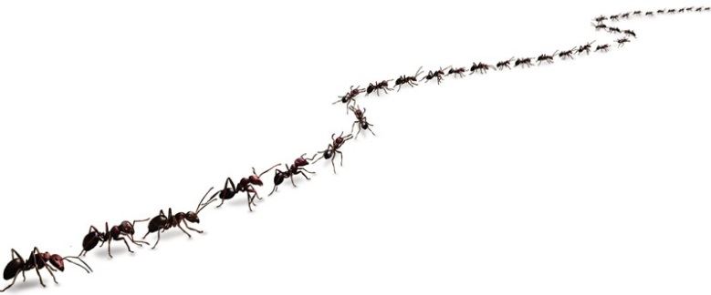

Scouting Spirit

Tune: "Joy in My Heart"

I've got that Scouting spirit,
Up in my head,
Up in my head,
Up in my head,
I've got that Scouting spirit,
Up in my head,
Up in my head to stay.
I've got that Scouting spirit,
Deep in my heart
continue as in first verse
I've got that Scouting spirit,
Down in my feet
continue as in first verse
I've got that Scouting spirit,
All over me
continue as in first verse
I've got that Scouting spirit,
Up in my head,
Deep in my heart,
Down in my feet,
I've got that Scouting spirit,
All over me,,
All over me to stay.

The Quartermaster's Song
There are snakes, snakes, snakes
Big as garden rakes,
At the store! At the store!
There are snakes, snakes, snakes,
Big as garden rakes, at the Quartermaster's store.
Chorus
My eyes are dim I can-not see.
I have not got my specs with me.
I have HEY! Not HO! got my specs with me.
There are mice, mice, mice
Running though the rice,
At the store! At the store!
There are mice, mice, mice,
Running through the rice, at the Quartermaster's store.
Chorus
Continue with each of the following:
lice - living on the mice.
rats - big as alley cats.
roaches - big as football coaches
snakes - big as garden rakes
bears - but no one really cares
beavers - with little meat cleavers
foxes - stuffed in little boxes
Mice . . . running through the rice.
Beans . . . as big as submarines.
Gravy . . . enough to float the navy.
Cakes . . . that give us tummy aches.
Eggs . . . with scaly chicken legs.
Butter . . . running in the gutter.
Lard . . . they sell it by the yard.
Bread . . . with great big lumps like lead.
Cheese . . . that makes you want to sneeze.

This Land is Your Land (Canadian Lyrics by The Travellers )
This land is your land, This land is my land,
From Bonavista, to Vancouver Island
From the Arctic Circle to the Great Lakes waters,
This land was made for you and me.
As I went walking that ribbon of highway,
I saw above me that endless skyway;
I saw below me that golden valley
This land was made for you and me.
I roamed and I rambled and I followed my footsteps,
To the sparkling sands of her diamond deserts;
While all around me a voice was sounding,
Saying this land was made for you and me.
The sun came shining, and I was strolling,
And the wheat fields waving and the dust clouds rolling;
As the fog was lifting, a voice was chanting,
This land was made for you and me.
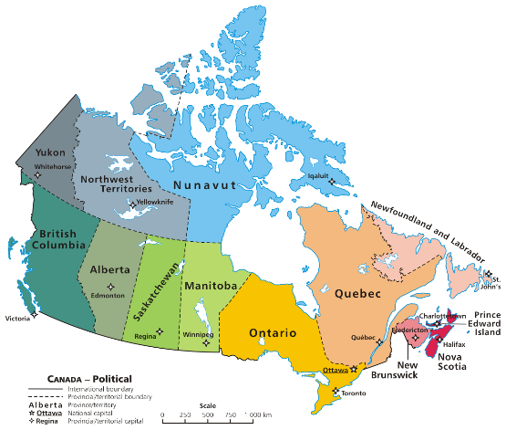
This land is your land, this land is my land,
From Bonavista to Vancouver Island;
From the Arctic Circle to the Great Lakes waters,
This land was made for you and me.

Land of the Silver Birch
My paddle's keen and bright
Flashing with silver
Follow the wild goose flight
Dip, dip and swing
Dip, dip and swing her back
Flashing with silver
Swift as the wild goose flies
Dip, dip and swing
Land of the silver birch
Home of the beaver
Where still the mighty moose
Wanders at will
Blue lake and rocky shore
I will return once more
Boom-diddy-ah-da, Boom-diddy-ah-da, Boom-diddy-ah-da, bo-oo-oom
High on a rocky ledge
I¹ll build my wigwam
Close to the water¹s edge
Silent and still
Blue lake and rocky shore
I will return once more
Boom-diddy-ah-da, Boom-diddy-ah-da, Boom-diddy-ah-da, bo-oo-oom
My heart grows sick for thee
Here in the lowlands
I will return to thee hills of the north
Blue lake and rocky shore
I will return once more
Boom-diddy-ah-da, Boom-diddy-ah-da, Boom-diddy-ah-da, bo-oo-oom
Land of the silver birch
Home of the beaver
Where still the mighty moose
Wanders at will
Blue lake and rocky shore
I will return once more
Boom-diddy-ah-da, Boom-diddy-ah-da, Boom-diddy-ah-da, bo-oo-oom

Linger
Hmmm, I want to linger. Hmmm, A little longer.
Hmmm, A little longer, Here with you.
Hmmm, It's such a perfect night. Hmmm, It doesn't seem quite right. Hmmm, That this should be,
My last with you.
Hmmm, And come September, Hmmm, I will remember, Hmmm, Our Scouting days,
Of friendships true.
Hmmm, And as the years go by, Hmmm, I'll think of you and sigh. Hmmm, This is good night
And not good bye.
Hmmm I want to linger. Hmmm A little longer.
Hmmm A little longer, Here with you.

Black Socks

Sing as a two-part round, one half singing the "verse" and the other half "not yet, not yet, etc."

Black socks, they never get dirty,
The longer you wear them the stronger they get.
Sometimes I think I should wash them,
But something inside me says No, no, not yet.
Not yet, not yet, not yet...

There's a hole in the bucket, dear Liza, dear Liza,
There's a hole in the bucket, dear Liza, a hole.
Then mend it, dear Henry, dear Henry, dear Henry,
Then mend it, dear Henry, dear Henry, mend it.
With what shall I mend it, dear Liza, dear Liza?
With what shall I mend it, dear Liza, with what?
With a straw, dear Henry, dear Henry, dear Henry,
With a straw, dear Henry, dear Henry, with a straw.
The straw is too long, dear Liza, dear Liza,
The straw is too long, dear Liza, too long,
Then cut it, dear Henry, dear Henry, dear Henry,
Then cut it, dear Henry, dear Henry, cut it.
With what shall I cut it, dear Liza, dear Liza?
With what shall I cut it, dear Liza, with what?
With a knife, dear Henry, dear Henry, dear Henry,
With a knife, dear Henry, dear Henry, with an knife.
The knife is too dull, dear Liza, dear Liza,
The knife is too dull, dear Liza, too dull.
Then sharpen it, dear Henry, dear Henry, dear Henry
Then sharpen it, dear Henry, dear Henry, sharpen it.
On what shall I sharpen it, dear Liza, dear Liza?
On what shall I sharpen it, dear Liza, on what?
On a stone, dear Henry, dear Henry, dear Henry,
On a stone, dear Henry, dear Henry, a stone.
The stone is too dry, dear Liza, dear Liza,
The stone is too dry, dear Liza, too dry.
Well wet it, dear Henry, dear Henry, dear Henry,
Well wet it, dear Henry, dear Henry, wet it.
With what shall I wet it, dear Liza, dear Liza?
With what shall I wet it, dear Liza, with what?
Try water, dear Henry, dear Henry, dear Henry,
Try water, dear Henry, dear Henry, water.
In what shall I fetch it, dear Liza, dear Liza?
In what shall I fetch it, dear Liza, in what?
In a bucket, dear Henry, dear Henry, dear Henry,
In a bucket, dear Henry, dear Henry, a bucket.
There's a hole in my bucket, dear Liza, dear Liza,
There's a hole in my bucket, dear Liza, a hole.
Use your head, then! dear Henry, dear Henry, dear Henry,
Use your head, then! dear Henry, dear Henry, use your head!
There's A Hole In The Bottom Of The Sea
There's a hole in the bottom of the sea
There's a hole in the bottom of the sea
There's a hole, there's a hole
There's a hole in the bottom of the sea
There's a log in the hole in the bottom of the sea
There's a log in the hole in the bottom of the sea
There's a hole, there's a hole
There's a hole in the bottom of the sea
There's a bump on the log in the hole in the bottom of the sea
There's a bump on the log in the hole in the bottom of the sea
There's a hole, there's a hole
There's a hole in the bottom of the sea
There's a frog on the bump on the log
In the hole in the bottom of the sea
There's a frog on the bump on the log
In the hole in the bottom of the sea
There's a hole, there's a hole
There's a hole in the bottom of the sea
There's a…
There's a fly on the frog on the bump on the log
In the hole in the bottom of the sea
There's a fly on the frog on the bump on the log
In the hole in the bottom of the sea
There's a hole, there's a hole
There's a hole in the bottom of the sea
There's a wing on the fly on the frog
On the bump on the log in the hole in the bottom of the sea
There's a wing on the fly on the frog
On the bump on the log in the hole in the bottom of the sea
There's a hole, there's a hole
There's a hole in the bottom of the sea
There's a bee on the wing on the fly
On the frog on the bump on the log
In the hole in the bottom of the sea
There's a bee on the wing on the fly
On the frog on the bump on the log
In the hole in the bottom of the sea
There's a hole, there's a hole
There's a hole in the bottom of the sea
There's a hole, there's a hole
There's a hole in the bottom of the sea
There's a hole, there's a hole
There's a hole in the bottom of the sea
There's a hole, there's a hole
There's a hole in the bottom of the sea

My Bonnie
Song by The Beatles
Lyrics
My Bonnie lies over the ocean,
My Bonnie lies over the sea.
My Bonnie lies over the ocean.
Oh bring back my Bonnie to me.
My Bonnie lies over the ocean,
My Bonnie lies over the sea.
Well my Bonnie lies over the ocean.
Yeah bring back my Bonnie to me.
Yeah bring back, ah bring back,
Oh bring back my Bonnie to me to me.
Oh bring back, oh bring back,
Oh bring back my Bonnie to me.
Well my Bonnie lies over the ocean,
My Bonnie lies over the sea.
Yeah my Bonnie lies over the ocean.
Oh I said bring back my Bonnie to me.

Yeah bring back, ah bring back,
Oh bring back my Bonnie to me to me.
Oh bring back, ah bring back,
Oh bring back my Bonnie to me.
Actions
If group starts to sing this seated then whenever they sing a word that begins with a "B", then they stand; and vice versa.

Alice the Camel

Alice the camel has 4 humps, Alice the camel has 4 humps
Alice the camel has 4 humps so go Alice go
Boom Boom Boom
Alice the camel has 3 humps, Alice the camel has 3 humps
Alice the camel has 3 humps so go Alice go
Boom Boom boom
Alice the camel has 2 humps, Alice the camel has 2 humps
Alice the camel has 2 humps so go Alice go
Boom Boom boom
Alice the camel has 1 hump, Alice the camel has 1 hump
Alice the camel has 1 hump so go Alice go
Boom Boom boom
Alice the camel has 0 humps, Alice the camel has 0 humps
Alice the camel has 0 humps
Because Alice was a donkey.

The Hokey Pokey

You put your right hand in,
You put your right hand out,
You put your right hand in,
And you shake it all about,
You do the hokey pokey
and you turn yourself around
That what it's all about.

2) left hand
3) right foot
4) left foot
5) head
6) butt
7) whole self
Baby Bumble Bee

You may substitute people's names in place of 'my leader', 'my counselor', 'my scoutmaster', etc.

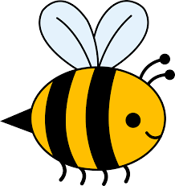
(cup hands carrying bee)
I found at camp a baby bumble bee
Won't my leader be so proud of me?
I found at camp a baby bumble bee...
Ouch! It stung me!
(squish hands together)
I'm squashing up my baby bumble bee
Won't my leader be so proud of me?
I'm squashing up my baby bumble bee...
Ew! What a mess!
(put hand in front of mouth like licking)
I'm licking up my baby bumble bee
Won't my leader be so proud of me?
I'm licking up my baby bumble bee...
Ugh! I feel sick!
(hold stomache and bend over)
I'm barfing up my baby bumble bee
Won't my leader be so proud of me?
I'm barfing up my baby bumble bee...
Oh! Another mess!
(pretend mopping, then stand tall and proud)
I'm mopping up my baby bumble bee
Won't my leader be so proud of me?
I'm mopping up my baby bumble bee...
Hey, leader, aren't you proud of me?
I found at camp a baby bumble bee
(clap loud)I got it before it got me!

Taps

© Pennsylvania Military College

Day is done, gone the sun,
From the lake, from the hills, from the sky;
All is well, safely rest, God is nigh.
Fading light, dims the sight,
And a star gems the sky, gleaming bright.
From afar, drawing nigh, falls the night.
Thanks and praise, for our days,
'Neath the sun, 'neath the stars, neath the sky;
As we go, this we know, God is nigh.
Sun has set, shadows come,
Time has fled, Scouts must go to their beds
Always true to the promise that they made.
While the light fades from sight,
And the stars gleaming rays softly send,
To thy hands we our souls, Lord, commend.

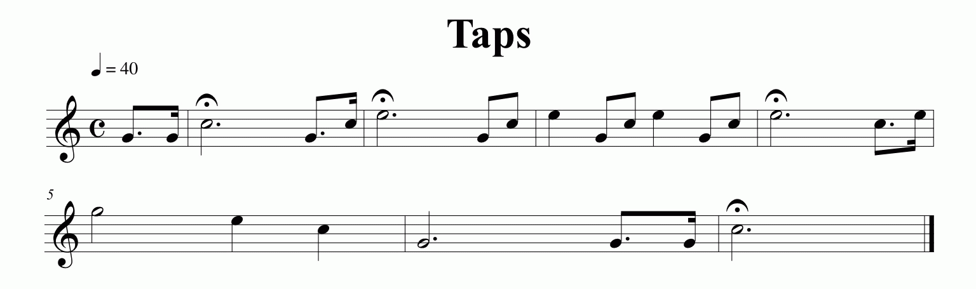

Kumbaya
Peter, Paul and Mary
Kumbaya my Lord, kumbaya
Kumbaya my Lord, kumbaya
Kumbaya my Lord, kumbaya
Oh Lord, kumbaya
Someone's singing Lord, kumbaya
Someone's singing Lord, kumbaya
Someone's singing Lord, kumbaya
Oh Lord, kumbayah
Someone's laughing, Lord, kumbaya
Someone's laughing, Lord, kumbaya
Someone's laughing, Lord, kumbaya
Oh Lord, kumbaya
Someone's crying, Lord, kumbaya
Someone's crying, Lord, kumbaya
Someone's crying, Lord, kumbaya
Oh Lord, kumbaya
Someone's praying, Lord, kumbaya
Someone's praying, Lord, kumbaya
Someone's praying, Lord, kumbaya
Someone's praying, Lord, kumbaya
Oh Lord, kumbaya
Someone's sleeping, Lord, kumbaya
Someone's sleeping, Lord, kumbaya
Someone's sleeping, Lord, kumbaya
Oh Lord, kumbaya
Oh Lord, kumbaya

Boom - chicka - Boom
I said a Boom - chicka - Boom (Repeat)
I said a Boom - chicka - Boom (Repeat)
I said a Boom - chicka wocka - chicka wocka - chicka boom (Repeat)
All right (Repeat)
O.k (repeat)
Now slow (1st time - go really slow)
Now fast (2nd time - go really fast)
Now high (3rd time - high voice)
Now deep (4th time - deep voice)
Now soft (5th time - get soft)
Now LOUD! (GET Really loud)
Finish with - All right, o.k, that it's it

Actions
Repeating the verse - after each time line is said, leader at the last line, says the action - then does the next verse with that action, loud, soft, etc.

Funky Chicken
I want to see your funky chicken Whats that you say?
I want to see your funky chicken Whats that you say?
Oh ah oh ah oh ah oh ah....(do chicken actions)
One more time
Oh ah oh ah oh ah oh ah....(do chicken actions)
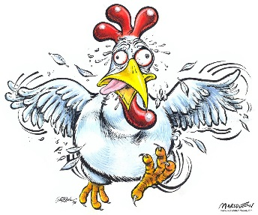
I want to see your funky grany Whats that you say?
I want to see your funky grany Whats that you say?
oh ah oh ah oh ah oh ah(do grany actions)
One more time
oh ah oh ah oh ah oh ah(do grany actions)

I want to see your funky auntie Whats that you say?
I want to see your funky auntie Whats that you say?
oh ah oh ah oh ah... (pretend to punch somthing)
One more time oh ah oh ah oh ah... (pretend to punch somthing)
I want to see your ballerina Whats that you say?
I want to see your ballerina Whats that you say?
oh ah oh ah oh ah oh ah(spin like a ballerina)
One more time oh ah oh ah oh ah oh ah(spin like a ballerina)
I want to see your dieing bug Whats that you say?
I want to see your dieing bug Whats that you say?
oh ah oh ah oh ah(lay down and squirm)
One more time oh ah oh ah oh ah(lay down and squirm)

My Name is Joe

Hey, My name is Joe
And I work in a button factory,
I've got a wife and a dog and a family,
One day the boss came up to me and said
Hey Joe, Are you busy? I said no,
He said turn the button with your _____.
1) Left hand
2) Right Hand
3) Left Foot
4) Right Foot
5) Butt
6) Tongue

Purple Stew

Making a purple stew, whip, whip
Whip Whip Whip (pretend to stir a huge bowl, circular motion with arms)
Making a purple stoobie-doobie-oobie-doobie
Purple potatoes, and purple tomatoes and (pretend to throw things in from over your shoulder)
You in my purple stew. (person in middle points to someone)
Fancy meeting you in my purple stew. (the two shake hands)
Everyone stands in a circle while one person stands in the middle. While you are singing the song perform the actions. When you say "You in my purple stew" the person in the middle points to someone and that person joins the middle. On "Fancy meeting you..." the person who was just pulled into the circle shakes hands with the person who brought him there.
---------------------
We’re making a purple stew,
Whip whip whip whip,
We’re making a purple stew,
Shoobie doobie doo.
With purple potatoes,
And purple tomatoes,
And and purple YOU.
*Action* Leaders point onto someone, that person stands and join the circle.

Penguins Attention

Lyrics
(Do a salute)Penguins Attention Penguins begin. (Pat right arm to side) Have you ever seen a penguin come to tee. Take a look at me a penguin you will see. (do a salute)Penguins Attention Penguins Begin.
Repeat that The 2nd time do both arms to the side
The 3rd time do arms and click right heel
The 4th time do arms and click both heels
The 5th time do arms and heels and Nod head up and down
The 6th time do arms and heels and head and spin around in place
The 7th time do arms and heels and head and spin and stick out tongue
The 8th time say penguins Attention Penguin dismissed!

Campfire Song Song
Let's gather 'round the campfire, and sing our campfire song.
Our -c-a-m-p-f-i-r-e- -s-o-n-g- song.
And if you don't think that we can sing it faster than you're wrong, but it'll help if you just sing alooong.
Patrick: bum, bum, buuum...
[Patrick attempts to sing in the background]
Spongebob [quite fast]:
-c-a-m-p-f-i-r-e- -s-o-n-g- song.
-c-a-m-p-f-i-r-e- -s-o-n-g- song,
And if you don't think that we can sing it faster than you're wrong,
But it'll help if you just sing alooong.
Spongebob [quite fast]:
-c-a-m-p-f-i-r-e- -s-o-n-g- song,
Patrick!
Patrick:
Song! -c-a-m-p-f-i-r-e-
Spongebob:
Squidward!
Squidward: [says nothing]
[About 2 seconds later]
Spongebob:
Gooood!
Spongebob:
It'll heeeelp, it'll heeeeeelp, if you just sing aloooooong!
[Spongebob does guitar smash]
[Patrick comes along with a drum smash on top of spongebob]
[Spongebob then pops out of the drums and yells out]:
Oooh yeah!

Ging Gang Gooli
Ging gang gooli, gooli, gooli, gooli, watcha,
Ging, gang goo, Ging, gang goo,
Ging gang gooli, gooli, gooli, gooli, watcha,
Ging, gang goo, Ging, gang goo.
Heyla, heyla sheyla,
Heyla sheyla, heyla ho,
Heyla, heyla sheyla,
Heyla sheyla, heyla ho.
Shalli-walli, shalli-walli, Shalli-walli, shalli-walli.
Oompa, oompa, oompa...
During the first World Jamboree B.P. was looking for a song that everyone could sing, no matter what their language was. Ging Gang Gooli was the result.
In the deepest darkest Africa there is a legend concerning the Great Gray Ghost Elephant. Every year, after the rains, the great gray ghost elephant arose from the mists and wandered throughout the land at dawn. When he came to a village, he would stop and sniff the air, then he would either go around the village or through it. If he went round the village, the village would have a prosperous year, if he went through it, there would be hunger and drought.
The village of War-Cha had been visited three years in a row by the elephant and things were pretty bad indeed. The village leader, Ging-Ganga was very worried, as was the village medicine man Hay-la-shay. Together, they decided to do something about the problem. Now Ging-Ganga and his warriors were huge men with big shields and spears. They decided to stand in the path of the elephant and shake their shields and spears at it to frighten it away. Hay-la-shay and his followers were going to cast magic spells to deter the elephant by shaking their medicine bags, as the elephant approached. The medicine bags made the sound - shalawally, shalawally, shalawally.
Very early in the morning of the day the Great Gray Ghost Elephant came, the villagers gathered at the edge of the village, on one side were Ging-Ganga and his warriors, (indicate right) and on the other was Hay-la-shay and his followers (indicate left). As they waited the warriors sang softly about their leader - Ging gang gooli, gooli, gooli, gooli, watcha, Ging, gang goo, Ging, gang goo, Ging gang gooli, gooli, gooli, gooli, watcha, Ging, gang goo, Ging, gang goo. As they waited the medicine men sang of their leader - Heyla, heyla sheyla, Heyla sheyla, heyla ho, Heyla, heyla sheyla, Heyla sheyla, heyla ho.
And they shook their medicine bags - Shalli-walli, shalli-walli, Shalli-walli, shalli-walli.
And from the river came the mighty great gray ghost elephant's reply - Oompa, oompa, oompa...
The elephant came closer, so the warriors beat their shields and sang louder (signal warriors to stand and beat their thighs in time) - Ging gang gooli, gooli, gooli, gooli, watcha, Ging, gang goo, Ging, gang goo, Ging gang gooli, gooli, gooli, gooli, watcha, Ging, gang goo, Ging, gang goo.
Then the medicine men rose and sang loudly - Heyla, heyla sheyla, Heyla sheyla, heyla ho, Heyla, heyla sheyla, Heyla sheyla, heyla ho. And they shook their medicine bags - Shalli-walli, shalli-walli, Shalli-walli, shalli-walli. And the mighty great gray ghost elephant turned aside and went round the village saying - Oompa, oompa, oompa... There was great rejoicing in the village and all the villagers joined in to sing .... Ging gang gooli....
Boom Chicka Boom Song 1
(repeat each line after song leader)
I said a Boom Chicka Boom, I said a Boom Chicka Boom
I said a Boom Chicka Rocka Chicka Rocka Chicka Boom
CHORUS:
Uh, huh, Oh yeah
One more time _________ style
Janitor Style:
I said a Broom Sweep-a Broom, I said a Broom Sweep-a Broom
I said a Broom Sweepa Mop-a Sweep-a Mop-a Sweep-a Broom
Surfer Style:
I said a dude chicka dude. I said a dude chicka dude
I said a dude chicka wipeout chicka WHOA chicka dude
Speeder Style:
I said a Vroom Squeela Vroom, I said a Vroom Squeela Vroom
I said a Vroom There’s a Coppa Betta Stoppa Chicka Boom
Outer Space Style:
I said a Moon Chicka Moon, I said a Moon Chicka Moon
I said a Mooon Chicka Rocka Take-a rocket to the moon
*To the tune of the Imperial March*
Boom boom boom chicka boom chicka boom
Boom boom boom chicka boom chicka boom
Boom boom boom chicka boom chicka boom
Boom boom boom chicka boom chicka boom
I said “no Luke, I am your father”
I said “no Luke, I am your father”
Oh yeah
Oh yeah
Alright
Alright

A Ram Sam Sam Song
A ram sam sam, a ram sam sam
Guli guli guli guli guli ram sam sam
A ram sam sam, a ram sam sam
Guli guli guli guli guli ram sam sam
A rafi, a rafi,
Guli guli guli guli guli ram sam sam
A rafi, a rafi,
Guli guli guli guli guli ram sam sam
Ram Sam Sam- Pound fist, right over left, then left over right
Guli guli, pull hands apart gesturing as if someone were gooey
A rafiq- Spin index finger on either side of the head.
Dumb Ways to Die
Tangerine Kitty
Set fire to your hair
Poke a stick at a grizzly bear
Eat medicine that's out of date
Use your private parts as Piranha bait
Dumb ways to die
so many dumb ways to die
Dumb ways to die-ie-ie
so many dumb ways to die
Get your toast out with a fork
Do your own electrical work
Teach your self how to fly
Eat a two week old unrefridgerated pie
Dumb ways to die
so many dumb ways to die
Dumb ways to die-ie-ie
so many dumb ways to die
Invite a psycho killer inside
scratch a drug dealer's brand new ride
take your helmet off in outer space
use a clothes dryer as a hiding place
Dumb ways to die
so many dumb ways to die
Dumb ways to die-ie-ie
so many dumb ways to die
Keep a rattle snake as a pet
sell both your kidneys on the internet
eat a tube of super glue
i wonder…

